PSP 2 Capitulo 10 software Design

software design

Design quelity has two parts: the quality has two parts: Quality of the design content, Quality of the design representation.

A poor representation can also make the design so hard to understand that its problems will not be recognized unit implementation or even later.

Framework in the object-oriented design(OOD)

Sustitute either of the words procedure or función for the words class, method and object.

The design Process, You generaly start a design by: defining the prouduct´s purpose, Gathering relevant data, Producing an overview design and Filling in the details.

These steps are not isolated sequential task, however they are cooperative, parallel activities.

Design involves Discovery and invention, and frecuently requires intuitive leaps from one abstraction level to another.

Design as a learning process The design thus there will likely be many feedback loops and iterative cycles.

In the design steps, the changes enormously complicate the design process.

The users defined new need, the designers make changes, and the implementers code and fix defects.

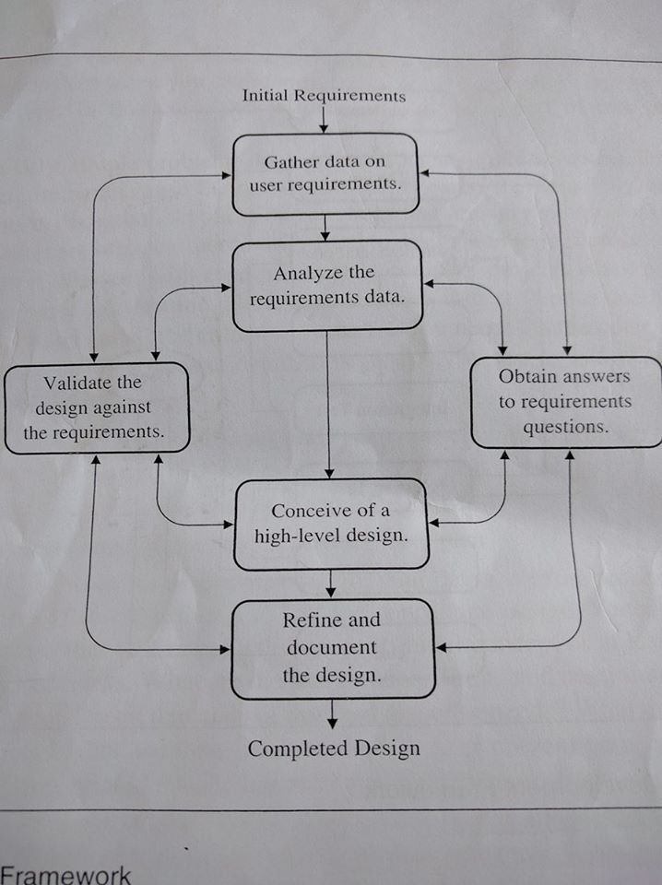

Freezing the design .- every new exposure leads to new knowledge, new ideas, and more changes.

The tricky problem for the developers is to trucate this learning process at just the right point so that a suitable product can be delivered in a reasonable time and at an affordable cost.

The PSP design process can help you make accurate plans and proposed quality products.

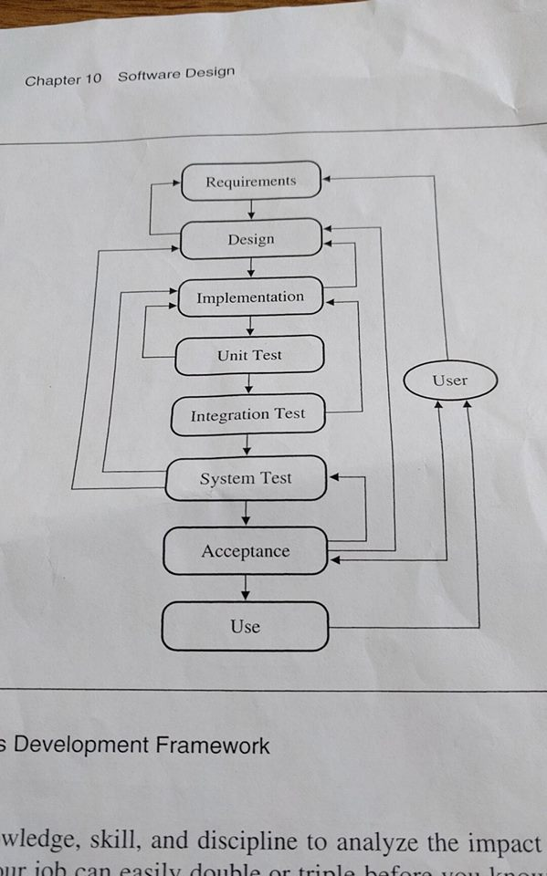

the conceptual design Focuse on the hight- level issues unit you know enought to produce the overall conceptual design. Complete and document the conceptual design. Now make and document your development plan. An immediate objective is to test the conceptual design.

Satisfafield yourself that th conceptual design is solid, you can begin to focues on details.

